**Lab Report**

Course Name : Electrical Circuits

Course Code : CSE209 LAB

Section No : 04

Experiment NO : 03

Experiment name : Bias Point Detail Analysis of DC Circuit With  
 Independent Sources Using PSpice Schematics.

**Submitted to**

Course instructor : Rashedul Amin Tuhin

Senior lecturer

Computer science and engineering

**Submitted by**

Name: Apurba Roy Ajay

Student’s ID : 2018-3-60-063

Department : Computer science and engineering

**Date of report submission : /09/2020**

**Objectives:**

1. To learn fundamentals of PSpice.
2. To analyze Bias Point Detail of DC circuit using PSpice Schematics.

**Circuit Diagram:**

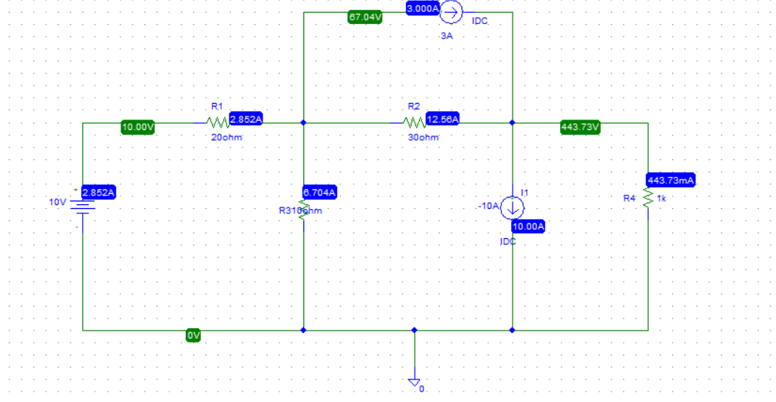

**Answer to the Post-Lab Report:**

1.

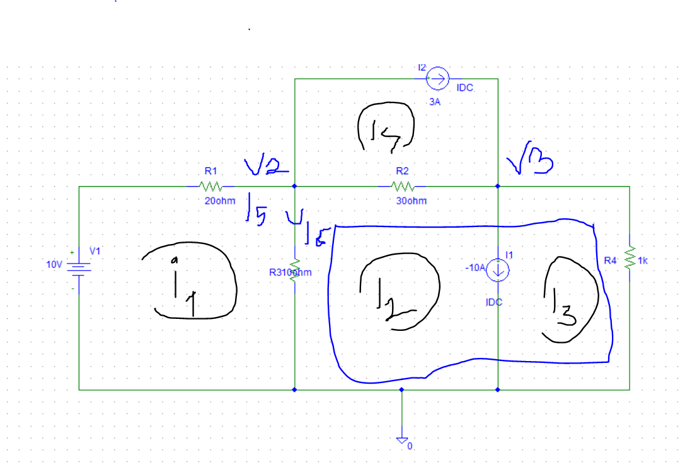

From the figure, $i_{4}$ 
 = 3A

KVL at mesh 1:  
 30 $i_{1}$- 10 $i_{2}$ = 10 ------------- (1)

KVL at Super-mesh:

- 10 $i_{1}$ + 40 $i_{2}$ + 10 $i_{3}$ = 90 ------------- (2)

And $i_{2}$ 
 – $i_{3}$ = -10 ------------- (3)

Solving equation (1), (2), and (3) using calculator , we get,

$i_{1}$ = 0.28571A = 285.71 mA,

$i_{2}$ = -0.14286A = -142.86 mA,

$i_{3}$ = 9.85714A = 9857.14 mA

So,

$i_{5}$ = $i_{4}$– $i_{2}$ = 3 + 0.14286 = 3.14286A = 3142.86 mA

And, $i_{6}$ 
 = $i_{1}$– $i_{2}$ = 0.28571 + 0.14286 = 0.42857A = 428.57 mA

Here,

$V_{2}$ = ($i_{5}× R_{1}$) = 3.14286 $×$ 30 = 94.2858 V

And,

$V_{3}$ = ( $i_{3}$ $× R_{4}$) = 9.85714 $×$ 10 = 98.5714 V

2.

Comparing the theoretical solution of the circuit obtained from above with the solution obtained from PSpice.

|  |  |  |
| --- | --- | --- |
|  | **PSpice** | **Calculated** |
|  | V1= 10 V | V1= 10 V |
| **Voltages** | V2 = 94.2858 V | V2 = 94.2858 V |
|  | V3 = 98.57 V | V3 = 98.5714 V |
|  | $i_{1}$ = 285.71 mA | $i_{1}$ = 285.71 mA |
|  | $i_{2}$ = 10 A | $i_{2}$ = 10A |
|  | $i_{4}$ = 3 A | $i_{4}$ = 3 A |
| **Currents** | $i_{3}$ = 9.86 A | $i_{3}$ = 9.85714 A |
|  | $i_{5}$ =3.143 A | $i_{5}$ =3.14286 A |
|  | $i_{6}$ = 428.57m A | $i_{6}$ = 428.57m A |

**Conclusion :**

We connect this circuit using Pspice software.I think if we could do this same experiment in the lab, the measure value would change a little bit and most importantly we could learn how to connect the circuit for real life.